Hey! We have a little test task for you. There are no restrictions, only the result is important.

You need to create a simple image classifier for Tuberculosis prediction. You can use the dataset from [here](https://www.kaggle.com/tawsifurrahman/tuberculosis-tb-chest-xray-dataset).

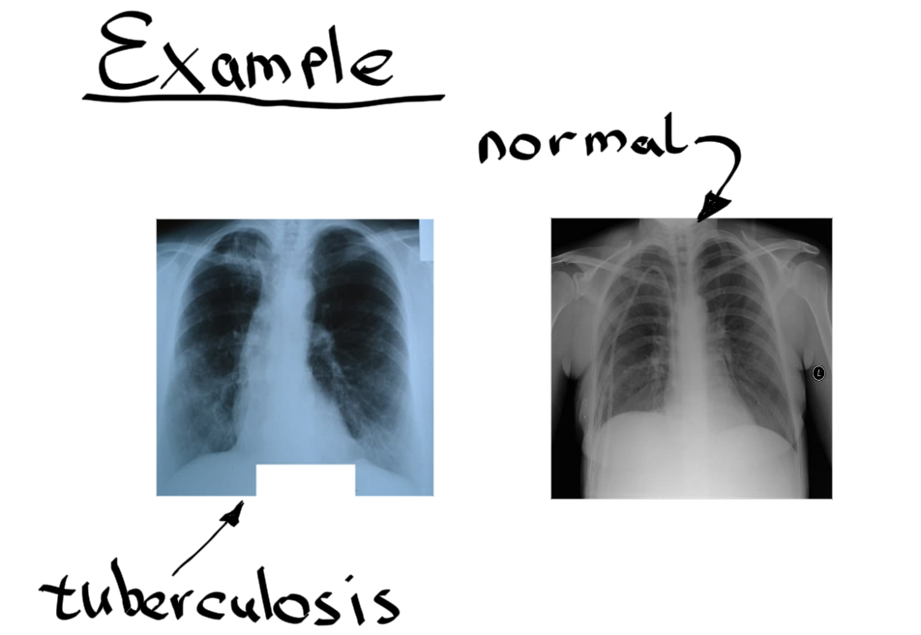

[To the Trello card.](https://trello.com/c/qal72WNJ/302-tuberculosis-classifier)